|  |  |
| --- | --- |
| cetlogo ***CHEMICAL ENGINEERING TRANSACTIONS***  ***VOL. 95, 2022*** | A publication of  aidiclogo_grande |
| The Italian Association  of Chemical Engineering  Online at www.cetjournal.it |
| Guest Editors: Selena Sironi, Laura Capelli  Copyright © 2022, AIDIC Servizi S.r.l. **ISBN** 978-88-95608-94-5; **ISSN** 2283-9216 | |

The Electronic Nose: review on sensor arrays and future perspectives

Giorgio Sberveglieric, Dario Genzardia, Giuseppe Grecob, Estefanía Núñez-Carmonaa, Simone Pezzottinib, Veronica Sberveglieria

aInstitute of Bioscience and Bioresources (CNR-IBBR), Via Madonna del Piano, 10, 50019 Sesto Fiorentino, FI, Italy;

bNano Sensor Systems, (NASYS) Spin-Off University of Brescia, Brescia, Via Camillo Brozzoni, 9, 25125 Brescia, BS, Italy.

cDepartment of Information Engineering, University of Brescia, 25123 Brescia, Italy;

giorgio.sberveglieri@nasys.it

Over the last 40 years, the term "electronic nose" (EN) has defined a device equipped with an array of not selective gas sensors capable of providing a response as a function of a stimulus provided by volatile chemical compounds (VOCs). Numerous studies have started from this idea, which have led to significant improvements and advantages, especially useful for providing a device capable of monitoring situations and applications in real-time. Applications that have strongly pushed the evolution of the “electronic nose” technology away from the laboratories and closer to more complex and stimulating real situations (Comini and Sberveglieri, 2010). One of the very initial goals of the EN was to simulate the mammalian nose to obtain a fast response regarding the characteristics of the analyte, high sensitivity for odours and high discrimination between them. In the last few years, a lot of upgrades have been made to the EN technology, thanks to artificial intelligence, machine learning evolutions, stability of the sensing elements, cloud processing, predictive algorithms, etc. Thanks to this strong commitment of all, this technology is reopening great interest in the industrial and consumers application field, managing to arrive directly in the transformation chains. The types of gas sensors used are various and are based on the modification of a physical or chemical parameter caused by the gases themselves. Conductometer sensors are the most common, being able to transduce a chemical signal in an electrical resistance signal. Other types of sensors have been developed and can be part of a functional array: Optical sensor, polymer sensor, electrochemical gas sensor, Quartz microbalances or SAW (Paolesse et al., 2017). In this presentation we will review the different sensor arrays most commonly used and a brief history of their evolution. From the point of view of sensor preparation technology, the one based on MEMS is becoming more and more widespread. A brief mention will also be made of the sensors used in the EN standard (called S3 +) made by Nano Sensor Systems S.r.l. spin-off of the University of Brescia. We will conclude by presenting the evolution of sensors in recent years to better understand how the multisensory, multidisciplinary and cloud computing approach has positively influenced the real potential of Electronic Noses.

* 1. Introduction

The concept of “electronic nose” was created for the first time in 1982 by Persaud and Dood (Persaud and Dood, 1982).They defined E-nose (EN) as an innovative tool equipped with an array of chemical a-specific sensors and appropriate pattern recognition system, capable of recognizing simple, or complex odors. The arrays, responsible for the final response, may be formed of different types of sensors. The most used are the semiconductor metal oxide sensors (MOS), which have been used with remarkable success in different fields such as food safety, quality control, environmental monitoring and human health. For instance, one of the possible applications of E-nose (Cipriano, 2018) has been the pathogen detection (Gobbi et al, 2010). Following this lead, the concept has undergone lots of upgrades. The major upgrades were in the structures and topology of gas sensors and in the analysis of sensor array data. In recent years there has been an imposing evolution of data analysis techniques using artificial intelligence in a massive way as an example machine learning with very innovative algorithms also taken from other completely different sectors such as the financial sector. These are in terms of system monitoring allowing to extend it both in technical terms, with the use of more suitable, sustainable and ensuring new possibilities like the use of data-driven modeling to perform rapid early detection of defect in production chain, leading the monitoring in a decision support system (Sanaeifar et al, 2017). As it was explained from Boonah et al (2020), it has been successful and superior to conventional methods. Another important application of EN is the use in AMSs (Automatic Measurement Systems), to monitor the emissions of contaminants into the air (Cipriano, 2018). As a matter of fact, E-nose offers a method that is non-invasive, fast and requires little or no sample preparation, thus making it a user friendly tool. Improvements about machine learning technologies have also been performed. These have been a crucial part of all these research which led to a rapid extension of EN related research topics with different applications (Karakaya, 2020).

* 1. Typologies of sensors in ENs

As previously mentioned, different types of chemical sensors have been selected for their sensitivity, stability and the ability to respond to complex gas spectra as usually are in the ENs (Figure 1) . Another fundamental parameter for sensor analysis is the reproducibility. As a matter of fact, once the database is formed and in the case of a malfunctioning of one sensor, the substitution must be safe and sure. Otherwise, the dataset might be collected again.

Figure 1 Main sensors used in Electronic Noses

Some of them, which can be part of sensor arrays, are consequently described:

**Optical sensors**: Optical sensors are a type of chemical sensor in which electromagnetic radiation is transduced in an analytical signal. These sensors can be based on various optical principles (absorbance, reflectance, luminescence, fluorescence), covering different regions of the spectra (UV, visible, IR, NIR) [Wolfbeis, 1991]. One of the applications of optical sensor arrays in Electronic Noses is the selective detection of gases, such as the determination of oxygen or carbon dioxide.

**SAW and Quartz microbalance sensors**: These are mass sensors where the parameters can change regarding the analyte. As a matter of fact, it is possible to assist to frequences and phases variations. These sensors are usually resonant structures made up of piezoelectric crystals or micro-cantilevers. Piezoelectric materials are used; as transducers and these range from quartz microbalances to surface acoustic wave devices.

Electrochemical sensors: Electrochemical sensors can be applied for the detection of gaseous analytes with the latter two most common. High temperatures can be accommodated using solid electrolytes and high temperature materials for sensor device construction. Overall, there are the following two main categories of electrochemical sensors (Karakaya et all, 2020):

****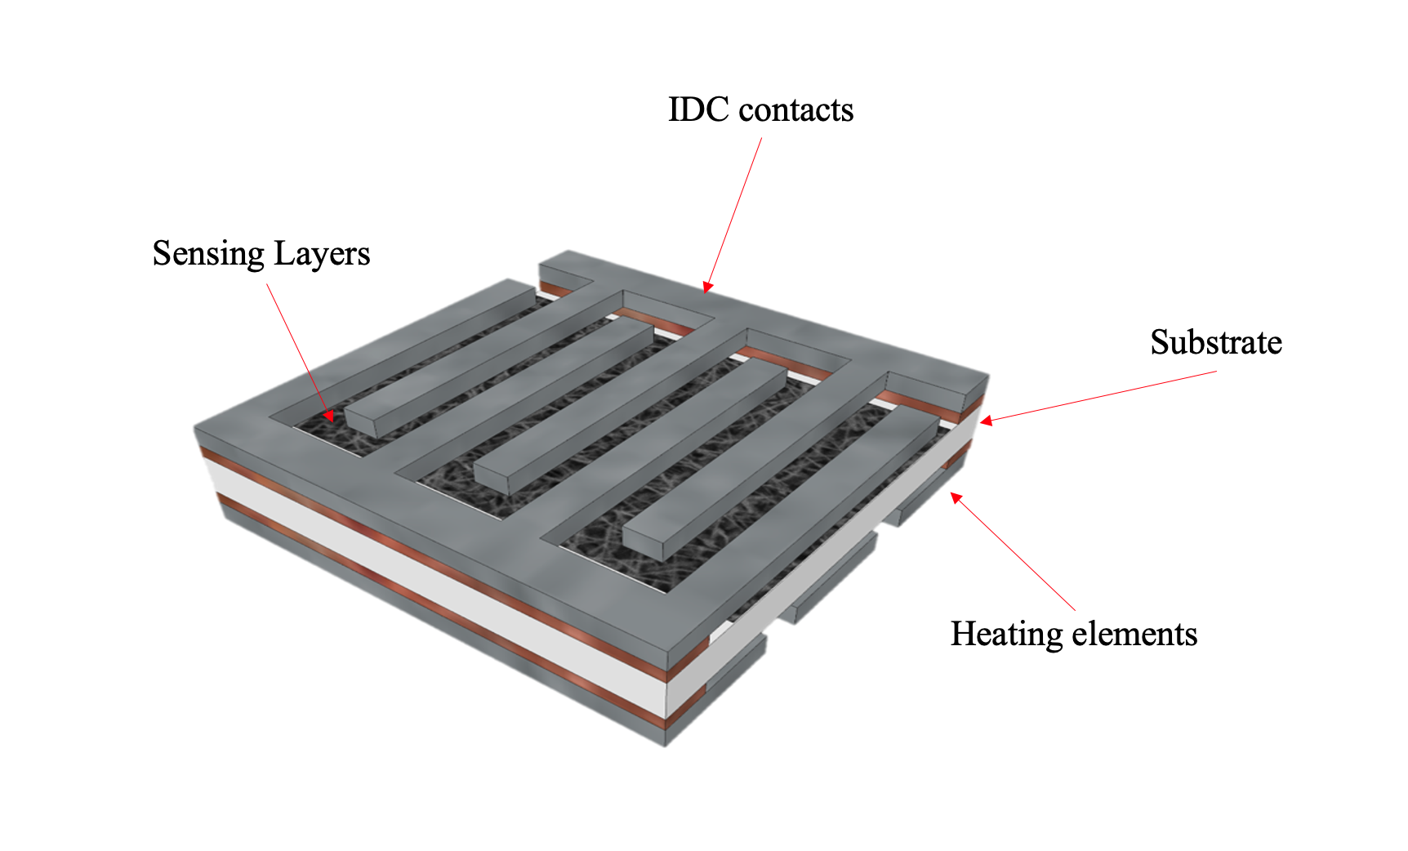**Chemiresistive**: Conductometric gas sensors, also named chemiresistors, transduce the presence in the atmosphere of a given chemical compound through a variation of their electrical resistance. They are based on semiconducting metal oxides, whose electrical properties are modulated by red-ox interactions with adsorbing gaseous molecules. It has been known for more than five decades that the electrical conductivity of metal oxide semiconductors (Figure 2) varies with the composition of the surrounding gaseous atmosphere. **I**n order to have MOS sensors with great stability even for long periods of use, the crystallite size has been reduced in the last 20 years to achieve a significant increase in sensor performance.

Figure 2 Typical structure of a conductometric MOX sensor.

The MOS sensor with reduced grain size show good sensitivity to many VOCs, short response time, a wide range of sensor coatings, low cost, good resistance to sensor poisoning, sensitivity to polar compounds. The second class of conductometric sensor used in ENs are the ones based on porphyrin (Catini et al, 2015). These are small size sensors with a very high sensitivity, rapid response and recovery times, comfortable to integrate into measurement circuitry. Both classes present the following negative aspects: sensitivity to humidity, not low power consumption, sulphur and weak acid poisoning, limited precision and limited reproducibility.

Figure 3 Wheaston bridge

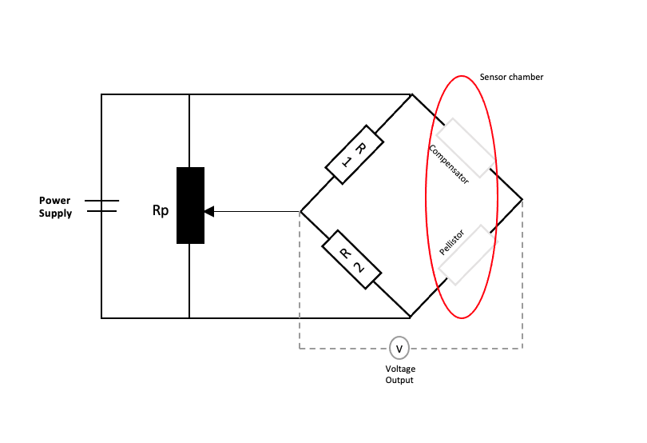One of the easiest and most sensitive methods to control electrical resistance in conductometric sensors is the Wheaston bridge (Figure 3).

Innovation about electronic nose

Recently, a lot of upgrades have been performed regarding the electronic nose. Several aspects have been improved such as artificial intelligence, machine learning, stability of the sensing elements, cloud processing, predictive algorithms and internal flow. With regard to this, Nano Sensor Systems srl , spin off of University of Brescia, developed a new Electronic Nose (Figure 4). This innovative tool is equipped with an array of 6/9 MOX sensors , flow, temperature and humidity sensors. The sensor responses are sent to the cloud on a platform on Microsoft Azure where they are processed with AI techniques and the result is sent to users. This EN has been successfully used in several applications such as microrganisms detection on food (Núñez-Carmona et all, 2020), characterization of EVOO (Abbatangelo et all, 2019) and coffee blends or jam recipes identification. As a matter of fact, an innovation study was performed regarding online detection of jam recipes in Menz&Gasser S.p.A., (Sede Legale Zona Industriale, 38050 Novaledo (TN), Italy) (Núñez-Carmona et all, 2019).

Figure 4 Nano Sensor Systems Electronic Nose

Nasys developed an array of three sensors (Figure 5) with different sensing layer on the same substrate, in order to achieve the right mechanical firmness and to reduce the power consumption of each sensor

Figure 5 Triple MOX sensors

**4.Conclusion**

The ENs have had considerable progress in recent years therefore they are able to give important information in a short time and continuously, which cannot be done with other techniques. One of the great advances that have enabled the development of new generations of ENs have been the much more stable and reproducible gas sensors. This characteristic associated with the new possibilities of data processing and the development of very robust predictive algorithms has meant that the real applications of ENs have multiplied. The success of some ENs in the various applications is also due to the fact that experts in different areas such as Physics, Chemistry, Electronic Engineering and Artificial Intelligence as well as the expert of specific applications give a strong contribution to their development.

**References**

Abbatangelo, M., Núñez-Carmona, E., Duina, G., & Sberveglieri, V. (2019). Multidisciplinary approach to characterizing the fingerprint of Italian EVOO. *Molecules*, *24*(8), 1457.

Bonah, E., Huang, X., Aheto, J.H. (2020). Application of electronic nose as a non-invasive technique for odor fingerprinting and detection of bacterial foodborne pathogens: a review. Food Sci Technol 57, 1977–1990.

Catini, A., Capuano, R., Paolesse, R., & Di Natale, C. (2015). Progettazione, realizzazione e test funzionali di un naso elettronico dedicato alla misura della qualità dei prodotti ortofrutticoli.

Cheng, L., Meng, Q. H., Lilienthal, A. J., & Qi, P. (2021). Development of compact electronic noses: A review. Measurement Science and Technology.

Cipriano, D. (2018). Application of EN14181 and EN15267 to electronic noses: Challenge or provocation?. *Chemical Engineering Transactions*, *68*, 139-144.

Clarós, P. Dąbkowska A2, Clarós A1.Portela A3, Pérez R3, Marimon X3, Gabarró MI3 and Gil J (2021). What is the “Status questionis” of the e-nose. The future of artificial nose. Journal of Bioscience & Biomedical Engineering.

Comini, E., & Sberveglieri, G. (2010). Metal oxide nanowires as chemical sensors. *Materials Today*, *13*(7-8), 36-44.

Gobbi, E., Falasconi, M., Concina, I., Mantero, G., Bianchi, F., Mattarozzi, M., ... & Sberveglieri, G. (2010). Electronic nose and Alicyclobacillus spp. spoilage of fruit juices: An emerging diagnostic tool. *Food Control*, *21*(10), 1374-1382.

J. W. Gardner and P. N. Bartlett, Eds., *Sensors and Sensory Systems for the Electronic Nose*, (1992) Kluwer Academic Publishers, London, UK,.

Jerónimo, P. C., Araújo, A. N., & Montenegro, M. C. B. (2007). Optical sensors and biosensors based on sol–gel films. Talanta, 72(1), 13-27.

Karakaya, D., Ulucan, O., & Turkan, M. (2020). Electronic nose and its applications: A survey. International journal of Automation and Computing, 17(2), 179-209.

Ma, H., Ding, E., & Wang, W. (2013). Power reduction with enhanced sensitivity for pellistor methane sensor by improved thermal insulation packaging. Sensors and Actuators B: Chemical, 187, 221-226.

Moseley, P. T. (1997). Solid state gas sensors. *Measurement Science and technology*, *8*(3), 223.

Nunez-Carmona, E., Abbatangelo, M., Zappa, D., Comini, E., Sberveglieri, G., & Sberveglieri, V. (2020). Nanostructured mos sensor for the detection, follow up, and threshold pursuing of campylobacter jejuni development in milk samples. *Sensors*, *20*(7), 2009.

Núñez-Carmona, E., Abbatangelo, M., Zottele, I., Piccoli, P., Tamanini, A., Comini, E., ... & Sberveglieri, V. (2019). Nanomaterial gas sensors for online monitoring system of fruit jams. *Foods*, *8*(12), 632.

O.S. Wolfbeis (1991). Fiber Optic Chemical Sensors and BiosensorsCRC Press, Boca Raton.

Paolesse, R., Nardis, S., Monti, D., Stefanelli, M., & Di Natale, C. (2017). Porphyrinoids for chemical sensor applications. *Chemical reviews*, *117*(4), 2517-2583.

Persaud K. and Dodd G. (1982). “Analysis of discrimination mechanisms in the mammalian olfactory system using a model nose,” *Nature*, vol. 299, no. 5881, pp. 352–355,

Persaud, K., & Dodd, G. (1982). Analysis of discrimination mechanisms in the mammalian olfactory system using a model nose. *Nature*, *299*(5881), 352-355.

Sanaeifar, A., ZakiDizaji, H., Jafari, A., & de la Guardia, M. (2017). Early detection of contamination and defect in foodstuffs by electronic nose: A review. TrAC Trends in Analytical Chemistry, 97, 257-271.